Using the Hotstart and Overrides Features in ResSim for the NWS CHPS Implementation
Overview
The original compute time window in ResSim was designed to include a lookback (or warm up period) and a simulation (or forecast) period. This allowed for the model to be used for both study simulations and real-time forecast modeling. The only caveat for real-time forecasting was that the lookback period covered the time where a full set of observed data was available and the start time was the time when all the observed data ran out (assuming the data ran out all at the same time) or the time of the “oldest” last reported observation).
This was understood by the Deltares developers who built the original wrapper for ResSim in the FEWS environment. The hard part for them was identifying the “right” simulation time and writing the observed data to be used for the lookback period into the simulation.dss file. But they did it and ResSim worked!
The Hotstart feature was added to ResSim at the request of the NWS to enable ResSim to fit in the NWSRFS modeling paradigm. At the time the Hotstart feature was designed and implemented, the modeling paradigm required that each model start from a saved state produced by a previous execution of that model. Thus, in ResSim, the Hotstart feature provides mechanisms for identifying when to:
- Save a state at a specified date/time or interval
- Start from a saved state
But, upon delivery of the Hotstart feature, the NWS explained the modeling paradigm in more detail and showed how starting from a warm state was only part of the story. The other part of the story was that observed data was to be used in the model after the warm start time/state up to the point when the observed data “runs out”. And, the model must handle the observed data running out at different times across the basin. With this new information, the question became “how do we use observed elevations and releases after the start time of the simulation?” The answer was to use the “overrides” concepts that are already part of ResSim. ResSim has a Release Override feature that has already been put to use by the FCO team and the NWS implementation in order to specify releases from the reservoirs to match what the operators/regulators “tell” NWS they will be releasing. The original implementation of the Release Override feature required the user to set (override) the release for each outlet at the reservoir in order to override the total release. This feature was expanded to allow the user to override the total reservoir release or the total dam release or the individual outlet release. This Release Override feature will be used to apply the observed releases into the simulation window up to the point the release “runs out”.
The Release Override option was also understood when the original ResSim wrapper was created. The Deltares developers created a means to allow the wrapper to write “overrides” data to the correct DSS file in the simulation tree.
The Elevation Target Override currently in ResSim is an override of an operational objective (the guide curve) rather than an override of the physical state of the reservoir. So, a Storage Override was added. The Storage Override can be defined in units of elevation or volume and represents a replacement for whatever ResSim may have calculated the storage to be at the end of the timestep – it WILL override the conservation of mass computations. This Storage Override will be used to reflect the observed pool elevations in the model up to the point the observations “run out”.
Thus, to fully implement the NWS modeling paradigm of starting from a warm state and using observed data to establish the physical state of the reservoirs, the Hotstart feature in conjunction with the Release and Storage Overrides will need to be used to apply the observed data that has been collected after the start time of the simulation (the hotstart time). Here are some details:
Hotstart Details
Hotstart settings are defined for an alternative on the Hotstart tab of the Alternative Editor which is illustrated below:
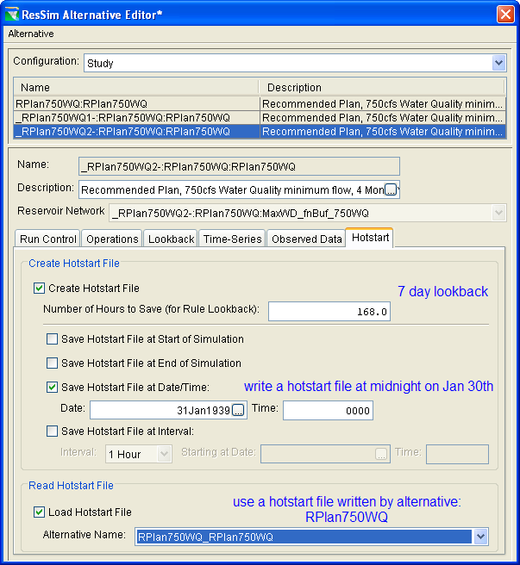
When an alternative in a simulation is told to write a hotstart file, two files (not just one) will be written to a mywatershed/rss/hotstarts folder (where mywatershed is the name of the current watershed). The filename of the hotstart files will reflect the time in the simulation at which the hotstart file was written and the name of the alternative that generated it.
The primary hotstart file (with the .nhs extension) reflects the state of the routing and other relevant elements at the point the file was generated.
The secondary hotstart file (with the .dss extension) is a dss file containing all model and state variable time series data needed to allow the model to pick up where it left off. The amount of data stored to the dss file is a function of the “Number of Hours to Save” setting in the Create Hotstart File options. This represents a minimum “lookback” period in case any rules or scripts require “previous” data.
The lookback time window of a simulation that writes a hotstart file should be at least as long as the “Number of Hours to Save” value. This value should be defined by the modeler and should reflect the longest of:
- Routing time from upstream-most reservoir to downstream-most control point
- Number of hours back that a rule or script must reference data (e.g., if a rule needs to get the 3day period average of inflow, then this would require 72hrs of saved data).
Determine the lookback time of a simulation that uses a hotstart file by subtracting the “number of hours to save” from the simulation start time. Actual lookback data should not be required for an alternative that uses a hotstart file.
The start time of a simulation that reads a hotstart file should match the date/time of an existing hotstart file. So, if the “write hotstart” always creates a hotstart at midnight, the simulation start time that uses it must start at midnight. A new simulation that has an alternative that will use a hotstart file looks for that hotstart file in the watershed/rss/hotstarts folder and will copy it to a rss/hotstarts folder in the simulation (mywatershed/rss/mysim/rss/hotstarts, where mysim is the name of the simulation).
The end time of the simulation is at the modeler’s discretion. A rule of thumb is that it should be longer than the routing time from the upstream-most reservoir to the downstream-most control point. In the NWS implementation, it should be the same end time as that used by the other models.
Below is an excerpt from a “running headless” command-line script that I modified to include all the options I could think of to set the hotstart settings without using the user interface. I sent this script to Edwin and Micha in April 2010.
simRun = simModule.getSimulationRun(altName)

true, false = 1, 0
print "About to hit hotstart stuff..."
#set hotstart options
# .. get the alternative
rssAlt = simRun.getRssAlt()
# .. get the options spec
print "Before getHotstartOptions"
opts = rssAlt.getHotstartOptions()
# .. turn on option to write hotstart files and define length of "lookback" to be saved with hotstart.
opts.setCreateHotstart(false)
opts.setHoursToSave(24)
# .. turn on save of a hotstart file at end of simulation
opts.setSaveAtEndofSim(true)
# .. turn on save of a hotstart file at end of lookback period
opts.setSaveAtLookback(true)

# .. turn on save of a hotstart file at specified intervals...
opts.setSaveAtInterval(true)
# .. create an HecTime object to be the start time of the intervals at which you save hotstart files
myHecTime = HecTime()
myHecTime.set("30Jun2009,24:00")
opts.setIntervalDateTime(myHecTime)
# .. specify the interval. Defining the interval is a little weird. It's a two-step process
# .. In the example below, I'm getting it to save every 12 hours.
opts.setTimeStep(12)
opts.setTimeIncrement(HecTime.HOUR_INCREMENT)

# .. turn on save of a hotstart file at a specific date and time
opts.setSaveAtDateTime(true)
myHecTime2 = HecTime()
myHecTime2.set("04Jul2009,18:00")
opts.setSaveAtDateTime(myHecTime2)

# This is the section you activate after you've written a hotstart file you want to use.
# .. turn on "use hotstart" and identify the alternative that wrote the hotstart to use.
# .. ResSim will figure out which file to use based on the simulation timewindow and the alternative name
# opts.setLoadHotstart(true);
# opts.setLoadAltName(altName);
rssAlt.setModified(true)

# .. since we are making the changes to the alternative after it is already in the simulation, then the
# hotstart files will not have been extracted when the simulation was created, so we must run the extract again. Grrr.
simPeriod=simRun.getSimulation()
simPeriod.runExtract(simPeriod.getSimulationExtract(ClientApp.Workspace()))
Release and Storage Overrides Details
The user interface for setting Overrides can be accessed from the Overrides option in the Simulation menu. The Release Overrides is the second tab and the Storage Overrides is the last one. When using release overrides, be sure you first select the right reservoir, then select the right outlet or level in the outlet dropdown list. If you want to override the total release from the pool, select the reservoir-pool. When using Storage Overrides, be sure to select either Storage or Elevation as the type of input you want to specify.
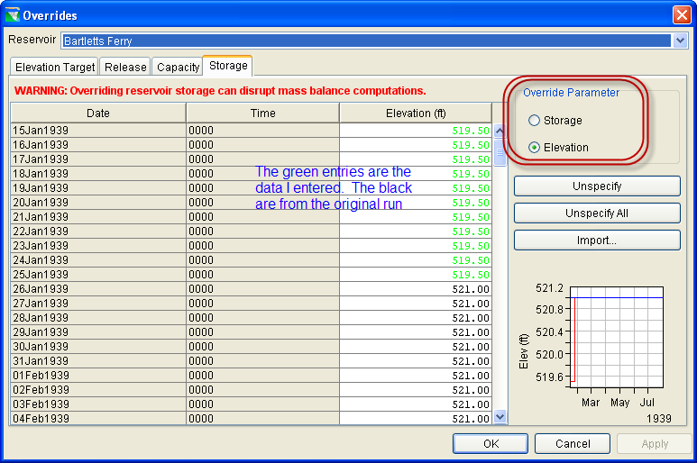
When specifying overrides from a “running headless” command-line script, there’s very little that the script needs to tell ResSim directly. In fact, with one exception, your scripts only need to take care of getting the observed data into the override records in the override file.
The override file is a dss file that has the “run name” of the RSS alternative and the file is in the rss subfolder of the simulation – myWatershed/rss/mySim/rss/myAlt-----0.dss where myAlt is the name of the alternative and myAlt-----0.dss is the name of the associated dss file that will be holding the override records. The override records in the dss file have the following dss pathname conventions:
- A part – blank
- B part – the reservoir name-the subelement name. Unless you’ll be overriding the releases by outlet, the subelement will always be the pool. So, if your reservoir name is Edwin, the B part would be “Edwin-Pool”. By the way, the pathname parts are case “insensitive” and can be converted to all upper case (which is what DSS will do with it).
- C part – Release Overrides use: “Flow-Release Override”
Storage Overrides use: “Storage Override” or “Elev-Storage Override”
- D part – you probably don’t need to specify this directly. This will be managed based on the time window of the data you write to the record
- E part – you also shouldn’t specify this part. HOWEVER, it is important to note that the overrides are written as IRREGULAR time series, not regular time series like the inflow data.
- F part - blank

Now – the one exception. Since the Storage Override provides the option for specifying the data as elevation or storage, you must tell ResSim which one to look for before the compute is launched. The call to do this is in the script snippet below:
simRun = simModule.getSimulationRun(altName)

rssRun = simModule.getRssRun(simRun.getName())
rssRun.setStorageOverrideType(ReleaseOverides.ELEV_STORAGE);

The first line above was in the other script snippet. If your script is doing both functions (and it probably should) then you do not need to duplicate this call.

The second line builds from that, it gets a more specific object, the RssRun. An interesting sub-portion of this line is the “getName” call from the simRun. This call can be used when setting up the overrides file. I believe it is the base name of the overrides dss file.

The third line in code snippet above is the one that actually tells ResSim what to look for when doing Storage Overrides. There are two possibilities for the argument to the “setStorageOverrideType” call. They are: ReleaseOverrides.ELEV_STORAGE for specification in units of elevation or ReleaseOverides.STORAGE for specification in units of storage. These entries are case sensitive so be careful to put them in your code exactly as shown.

